**Note – UI reference which I used i.e.** [**https://startbootstrap.com/templates/small-business/**](https://startbootstrap.com/templates/small-business/)**; Tool : CF10, Eclipse, Jquery, Bootstrap**

**Step to deploy :-**

1. **Restore database from TestAssignment.bak in MS SQL**
2. **Create DSN in ColdFusion administrator**
3. **Unzip source code like below location as I have in screen shot**

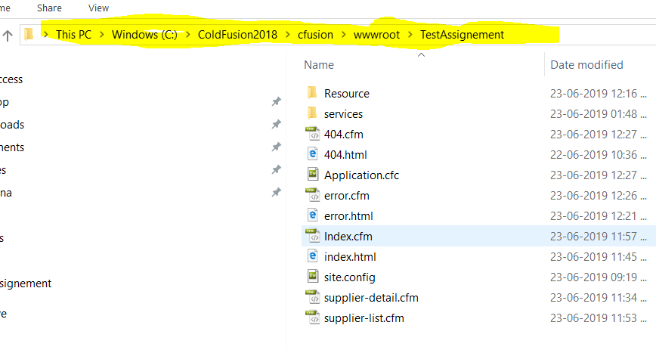

1. **Make require changes in site.config/Application.cfc file like DSN Name, app path etc.**
2. **When you run application with (**[**http://127.0.0.1:8500/TestAssignement/index.cfm**](http://127.0.0.1:8500/TestAssignement/index.cfm)**) you will get below four screens**

**1. Index Page**

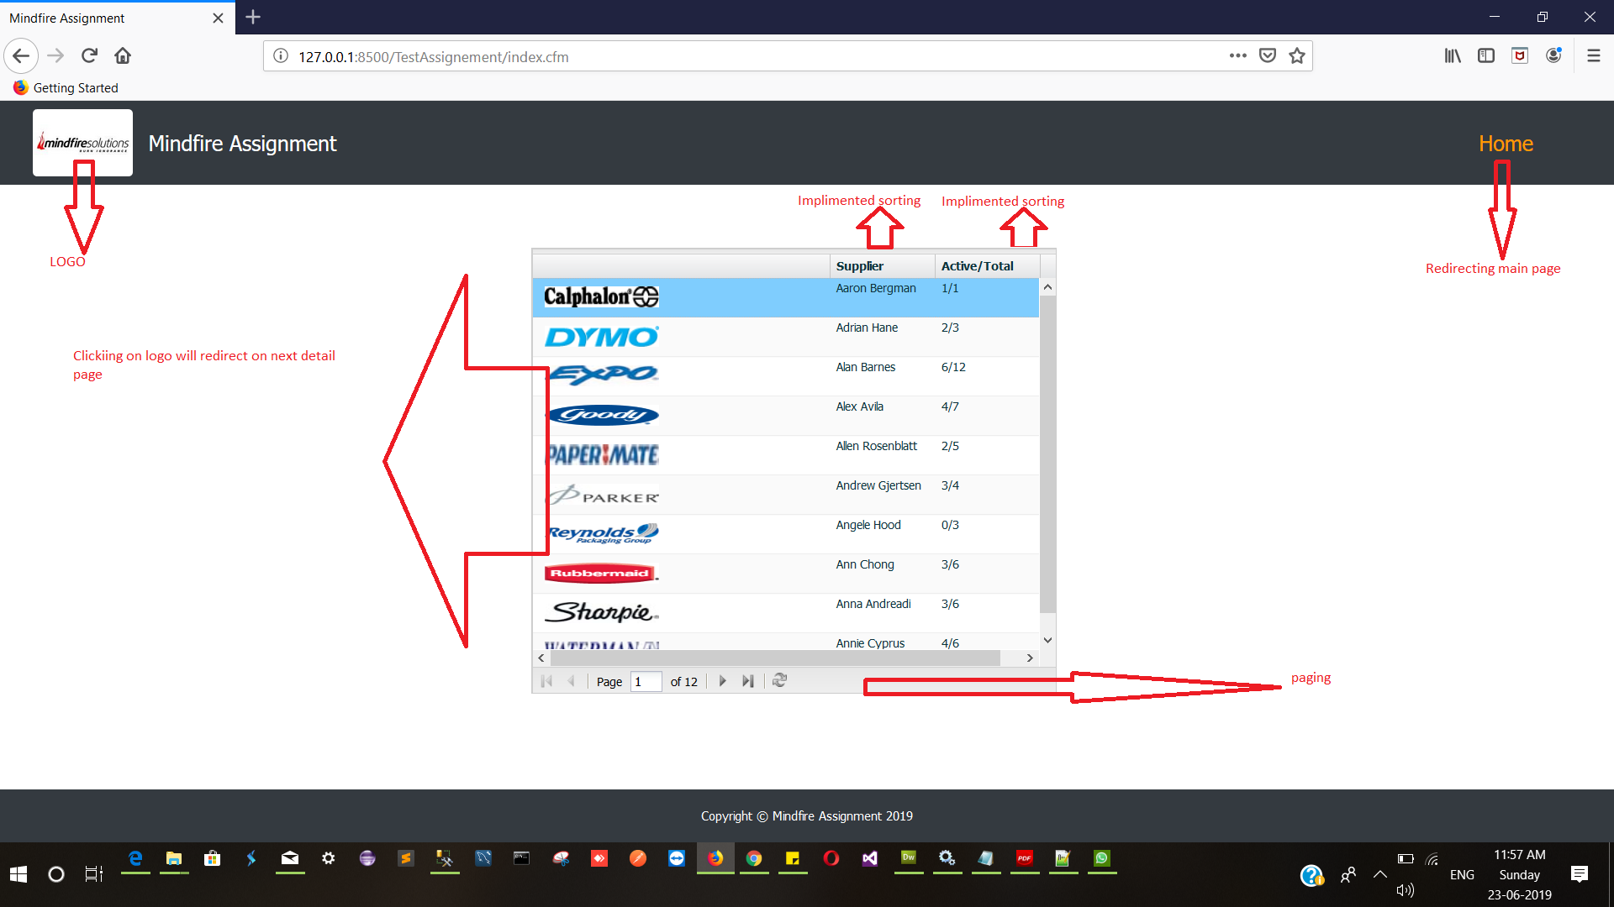

**2. Detailed Page**

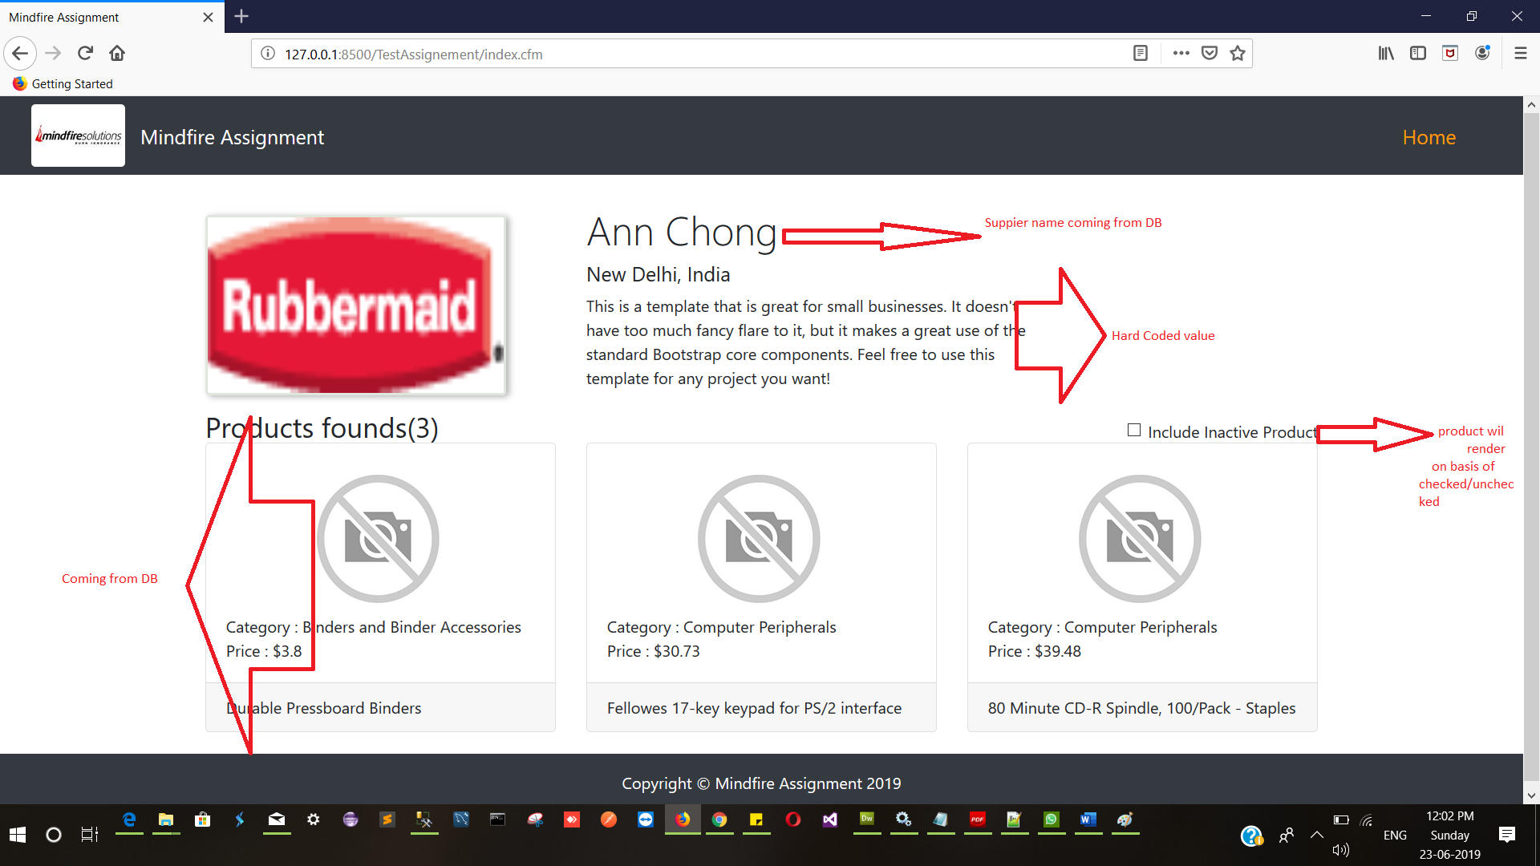

**3. Page Not found Page**

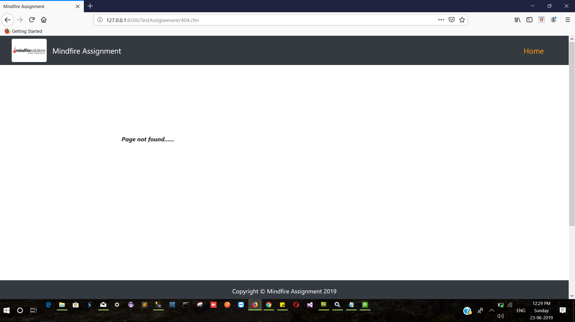

**4. Error Page**

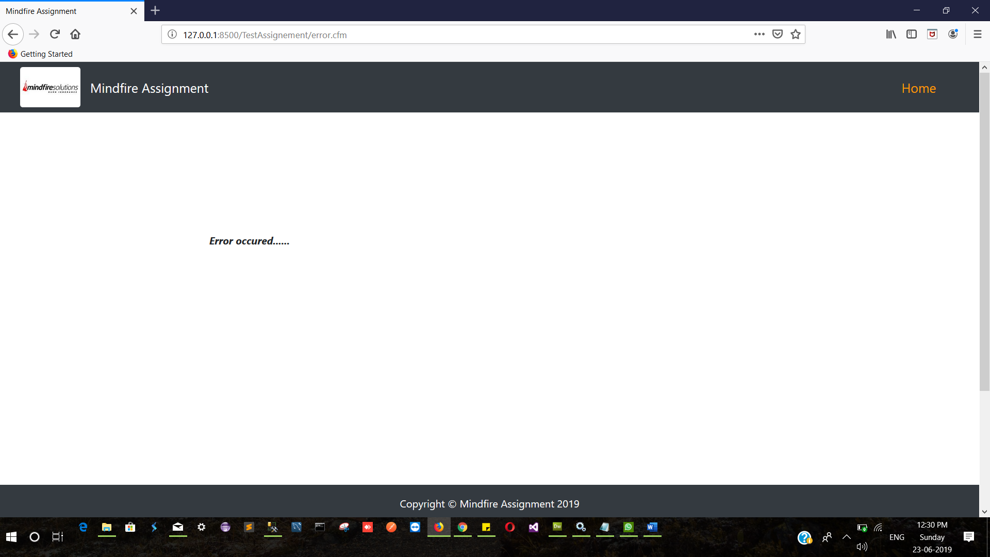

**DB – MS SQL**

